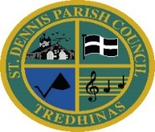
ST DENNIS PARISH COUNCIL

The Claytawc Centre
Fore Street
St Dennis Email: clerk@stdennisparishcouncil.org,uk
St Austell Website: www.stdennisparishcouncil.org.uk
PL26 8AF Urgent Tel No: 07464120377
NOTICE OF Skate park closure
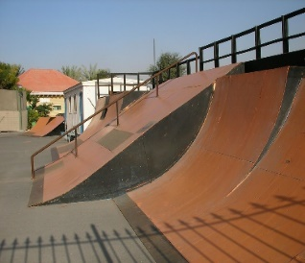
AS FROM MONDAY 11TH SEPTEMBER 2023 FOR APPROXIMATELY 4 DAYS THE SKATE PARK WILL BE CLOSED FOR ESSENTIAL REPAIRS AND RE-SURFACING
This Photo by Unknown Author is licensed under CC BY-NC
THE AREA WILL BE FENCED OFF AS FROM MONDAY 11TH SEPTEMBER AND WILL RE-OPEN AS SOON AS THE WORK IS COMPLETE
DURING THIS TIME ACCESS IS NOT PERMITTED TO ALLOW TIME FOR THE SPECIAL SEALANT TO CURE. THIS WILL AVOID DAMAGE TO THE SURFACE

THE SKATE PARK WILL RE-OPEN AS SOON AS POSSIBLE AS WE KNOW THAT IT WILL BE GREATLY MISSED

THANKS FOR YOUR CO-OPERATION ON THIS

*** KEEP AN EYE ON OUR FACEBBOOK
PAGE / WEBSITE FOR THE RE-OPENING DATE ****

